**Moussaka**

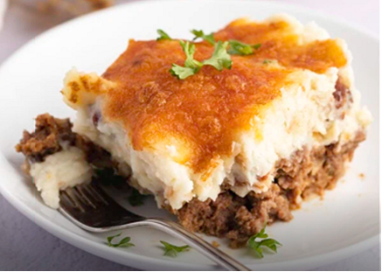

**INGREDIENTS**

* 1 pound ground beef
* 3/4 cup finely chopped yellow onions
* 1/3 cup seasoned dry bread crumbs
* 1/4 cup sweet honey barbecue sauce (i.e. Kraft)
* 1 egg, beaten
* 2 teaspoons chili powder
* 1 (24-ounce) package Ore-Ida Steam n’ Mash Russet potatoes
* 1 tablespoon butter or margarine
* 1 (5-ounce) can evaporated milk
* 1 tablespoon chopped fresh parsley
* 1 teaspoon garlic powder
* 1/4 cup French fried onions
* 2/3 cup shredded Cheider cheese

### DIRECTIONS

1. Preheat the oven to 375 degrees Fahrenheit. Grease a 9-inch square baking dish with baking spray.
2. In a large bowl, stir together the ground beef, onions, bread crumbs, barbecue sauce, beaten egg, and chili powder just until well-combined. Press the meat mixture into the bottom of the greased baking dish.
3. Bake it for 20 to 25 minutes, or until cooked through. Test for doneness with a meat thermometer. It should read 160 degrees Fahrenheit.
4. While baking, microwave the potatoes according to package instructions in a medium, microwave-safe bowl. Mix in the butter, milk, parsley, and garlic powder until well-combined. Gently mix in the French-fried onions.
5. Remove the dish from the oven and turn on the broiler. Top the meat mixture with the potato mix, followed by the shredded cheese.
6. Place the baking dish 4 inches from the heat. Broil for 3 to 5 minutes or until the cheese melts. Let the meatloaf rest for 10 to 15 minutes before slicing.

Serve and enjoy!